M06: Project Introduction and Status Report

Nick Boyd

2021-09-28

**Description:**

My program will be for Crazy Joe’s Amusements which is a family focused amusement park. The color scheme will be green and brown

**Main Form:**

The main form of the program will be for purchasing tickets to the park. The form will require a name, address, and e-mail from the user. The user will be able to select any number of either regular priced adult tickets or less expensive child/senior tickets. There will also be the option to select additional products such as food vouchers and a fast-pass system to skip the queue lines.

**Order Form:**

The order form will display all of the user entered information along with the numbers and types of all purchased items. It will show the final price and will give the user a chance to confirm the order or cancel.

**Other Information:**

The prices for the items will be:

* Adult Ticket: $50
* Child/Senior Ticket: $25
* Fast Pass: $10
* Meal Voucher: $10

**UI Elements:**

Main Window:

* lblHeader: label, displays “Crazy Joe’s Amusements”
* lblName: label, displays “Name”
* lblAddress: label, displays “Street Address”
* lblEmail: label, displays “E-mail”
* lblAdult: label, displays “Adult Ticket ($50.00)”
* lblChild: label, displays “Child/Senior Ticket ($25.00)”
* lblVoucher: label, displays “Meal Voucher ($10.00)”
* lblFastPass: label, displays “FastPass ($10.00)”
* lblTotal: label, displays “Total Cost:”
* lblAdultCost: label, displays total cost of selected adult tickets
* lblChildCost: label, displays total cost of selected child tickets
* lblMealCost: label, displays total cost of selected meal vouchers
* lblFastPass: label, displays total cost of selected Fast Pass tickets
* lblTotalCost: label, displays total cost of all selection
* txtName: text box for entry of name, 100px
* txtAddress: text box for entry of street address, 100px
* txtEmail: text box for entry of e-mail address, 100px
* btnContinue: button for submitting information and continuing to Order Form
* btnClear: button to clear all entries
* spinboxAdult: spinbox for selecting number of Adult tickets
* spinboxChild: spinbox for selecting number of Child tickets
* spinboxVoucher: spinbox for selecting number of Meal Vouchers
* spinboxFastPass: spinbox for selecting number of Fast Pass tickets

Order Window:

* lblHeader: label, displays “Crazy Joe’s Amusements”
* lblName: label, displays “Name: <name>”
* lblAddress: label, displays “Street Address: <address>”
* lblEmail: label, displays “E-mail: <email address>”
* lblAdult: label, displays “Adult Ticket ($50.00) <qty price>”
* lblChild: label, displays “Child/Senior Ticket ($25.00) <qty price>”
* lblVoucher: label, displays “Meal Voucher ($10.00) <qty price>”
* lblFastPass: label, displays “FastPass ($10.00) <qty price”
* lblTotal: label, displays “Total Cost: <price>”
* btnOrder: button for submitting the order
* btnCancel: button to cancel and return to Main Window

**Window Positions:**

Main Window:

|  | *col 0* | *col 1* | *col 2* |
| --- | --- | --- | --- |
| *row 0* | lblHeader |  |  |
| *row 1* | lblName | txtName |  |
| *row 2* | lblAddress | txtAddress |  |
| *row 3* | lblEmail | txtEmail |  |
| *row 4* | lblAdult | spinboxAdult | lblAdultCost |
| *row 5* | lblChild | spinboxChild | lblChildCost |
| *row 6* | lblVoucher | spinboxVoucher | lblVoucherCost |
| *row 7* | lblFastPass | spinboxFastPass | lblFastPassCost |
| *row 8* | lblTotal |  | lblTotalCost |
| *row 9* | btnContinue |  | btnClear |

Order Window:

|  | *col 0* | *col 1* | *col 2* |
| --- | --- | --- | --- |
| *row 0* | lblHeader |  |  |
| *row 1* | lblName |  |  |
| *row 2* | lblAddress |  |  |
| *row 3* | lblEmail |  |  |
| *row 4* | lblAdult |  |  |
| *row 5* | lblChild |  |  |
| *row 6* | lblVoucher |  |  |
| *row 7* | lblFastPass |  |  |
| *row 8* | lblTotal |  |  |
| *row 9* | btnOrder |  | btnCancel |

**Events:**

btnContinue: Validates entries in txtName, txtAddress, txtEmail. Submits information to Order Window

btnClear: Clears all text boxes and resets spin boxes to 0

spinboxAdult: Increases/decreases number in box and updates lblAdultCost and lblTotalCost

spinboxChild: Increases/decreases number in box and updates lblChildCost and lblTotalCost

spinboxVoucher: Increases/decreases number in box and updates lblVoucherCost and lblTotalCost

spinboxFastPass: Increases/decreases number in box and updates lblFastPassCost and lblTotalCost

btnOrder: Ends the program

btnCancel: Returns to the Main Window will all information cleared.

**Validation:**

txtName: Required. Must not include numbers or symbols

txtAddress: Required. Must not include symbols.

txtEmail: Required. Must be a valid email format ([example@example.com](mailto:example@example.com)).

**Branding:**

The colors are brown and green. The forms will have a green background under the header section and a brown background for the rest of the form. Buttons will also be in green. One image will be a stylized “CJ” for Crazy Joe’s initials displayed in the top right corner of the Main Window and a theme park related image (Merry-Go-Round, Ferris Wheel, Roller Coaster, whatever I can find) image in the top right corner of the Order Window.

**What’s Completed:**

The layout of the labels, entry fields, and spin boxes is completed. The function of the spinboxes and updating of cost labels appears to be working correctly. The clear and continue buttons work with the continue button successfully bringing up the second window and importing most of the data from the first.

**Differences from Plan:**

While working on building the program I didn’t refer to this document and did a few things differently than I had planned. I did the backgrounds the opposite way I wrote here, the buttons were moved to the right side, and variable names aren’t consistent with this document. Placed images in both the top right and top left corners of the forms. The second form has the same column layout as the first unlike this document.

**Current Issues and To Dos:**

Entry verification needs to be completed. Need to figure out how to do email verification with the @ symbol. Need to complete getting information from the entry boxes to the second window. I’m not happy with the layout and need to make adjustments. In particular, I think the buttons need to be at the bottom and be more prominent. I don’t think the entire background being colored is user friendly. Need to clean up the code (when testing functions I commented out already working code that was put into the function). Second form needs buttons and functionality. Redo the CJ icon as size and color don’t match.

**Main Form:**

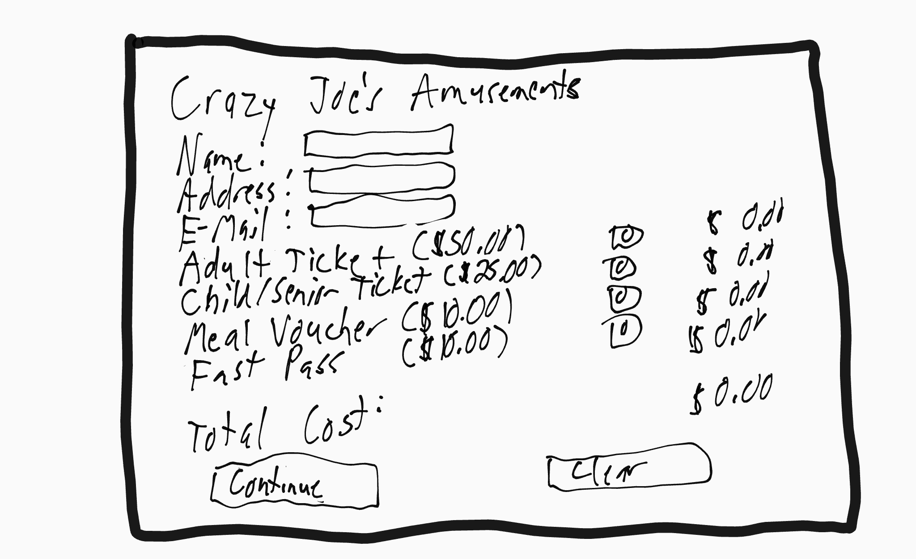

**Order Form:**